**Zombies ate my neighbor Game Design**

**First Person Shooter Game**

**Player Experience:**

* Intense, scary

**Core Mechanic:**

* Shoot enemies

**Core game loop:**

* Collect ammo, shoot enemies, reach end of level

**Game Flow and Screens**

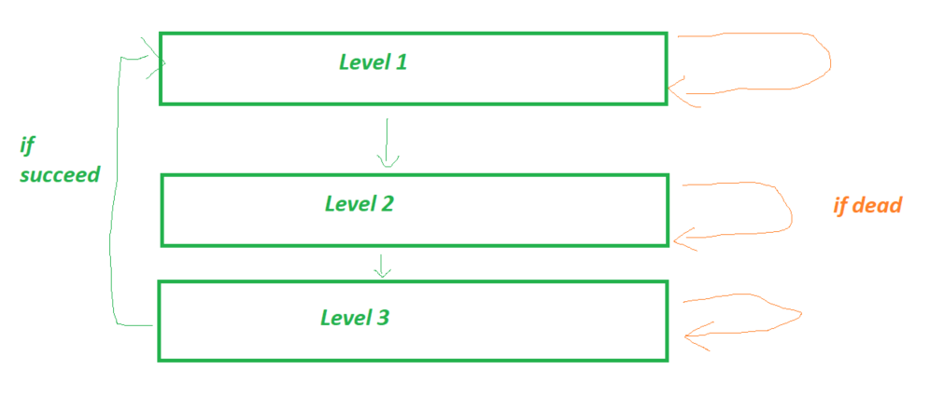

**Game Theme (ie. Story & Visuals:**

* Dark, Forest, Hospital, Monsters

**Game Theme (ie. Story & Visuals:**

* PC / Mac / Linux
* 1920x1080 16:9
* Input: Mouse

**Stretch Goals:**

**Onion design:**

Most important feature: First Person Camera Movement

2nd most important feature: Raycasting to shoot

3rd most important feature: Enemy attack and move AI

4th most important feature: Health and damage system

5th most important feature: Death/Game over

6th most important feature: weapon switching

7th most important feature: Ammo and ammo pickups

8th most important feature: flashlight and battery pickup

9th most important feature: probuilder geometry

All features need to feed the core and make it better

**Create moments for levels**

*Start with moment and than expand the environment around it*

e.g.

Fly under

Fly over

Fly through a gap

Time your flight through moving obstacle

Land on moving platform

Fly through narrow tunnel

*Or tuning moments*

e.g.

Slower rocket (got damaged)

Faster rocket (got a boost)

Darker level

Closer camera

Bigger rockt (carrying something

Reversed controls